Objective: To develop prediction model for combined thermal sensation and acceptance performance

Background:

The most common thermal comfort model / index in standards also showing thermal acceptance in indoor space for building design. Such as the Fanger’s model and adaptive model.

Method(s):

1. Classify thermal acceptance (0: unaccept, 1: accept)
2. Classify thermal sensation (Cool: TSV<-1.5, Neutral: -1.5<= TSV<= 1.5, Warm: TSV>1.5)
3. Combined thermal acceptance and sensation (6 levels)

Acc_cool, Acc_neu, Acc_warm, Unacc_cool, Unacc_neu, Unacc_warm

Findings:

Combined thermal acceptance and sensation against indoor temperature

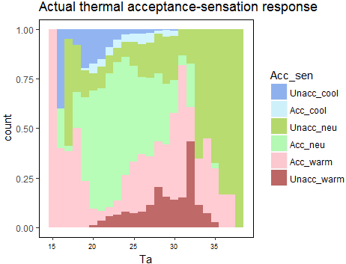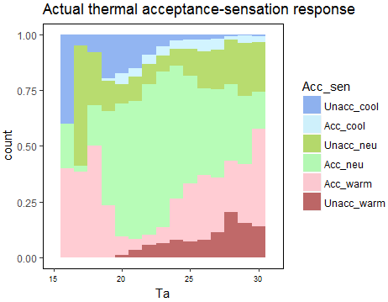

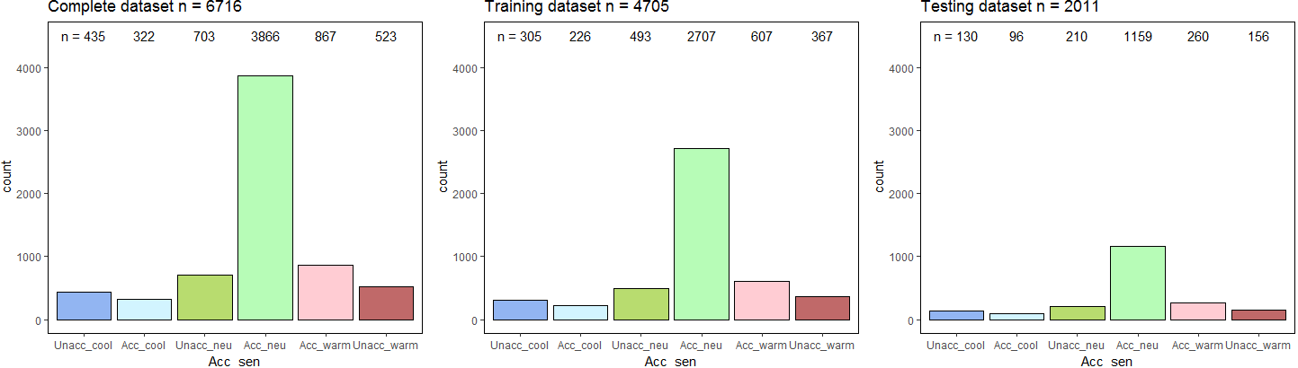

Model prediction results

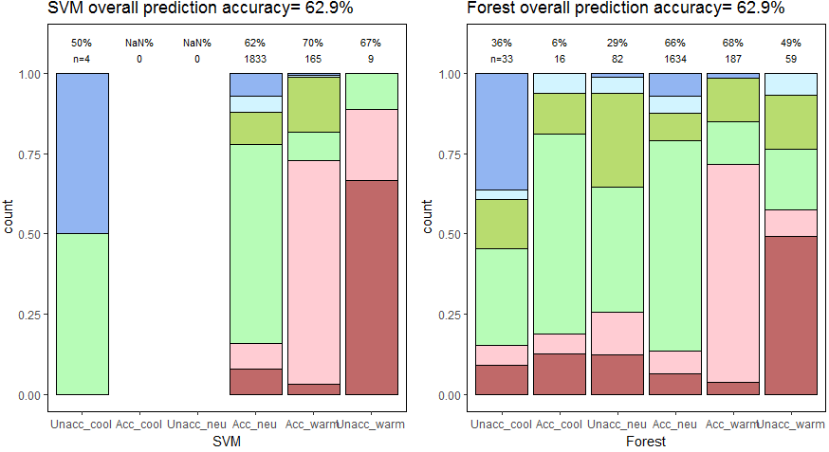

“n” is the number of prediction in each category by the model.

Applications:

Model performance plot against air temperature

**Testing data only**

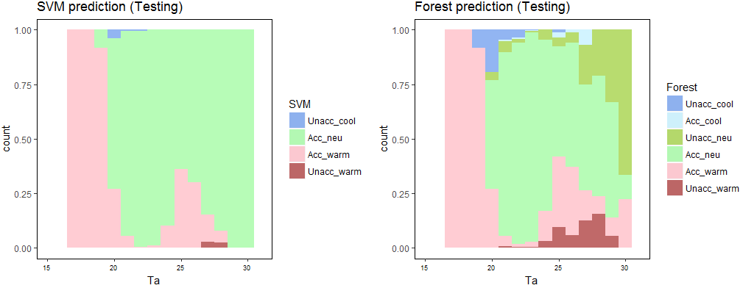

**Complete dataset: including both training and testing data**

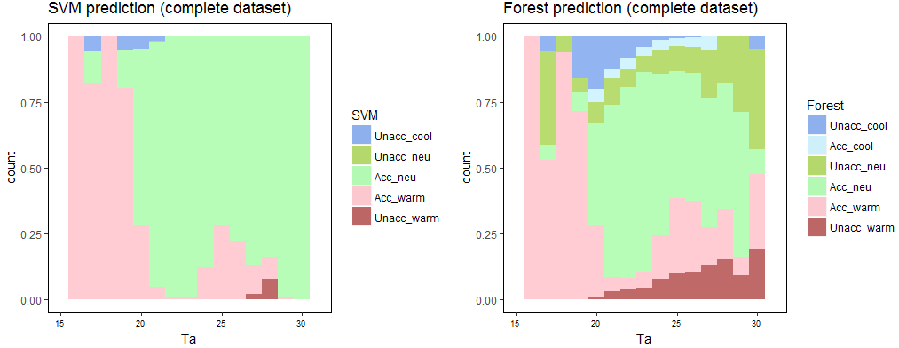

**Simulated dataset (n=10000)**

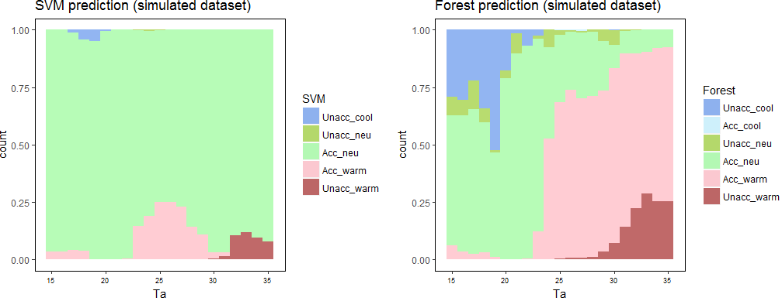

Simulated dataset (n=10000):

Ta: 15-35 °C

Tr = Ta

To: 5-40 °C

Clo: 0.3-1.1 clo

Met: 1-1.2 met

Rh: 45-85%

V: 0.01-0.2 ms-1